Science Communication International Summer School 2019.
University of Manchester.
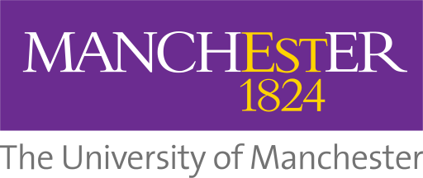
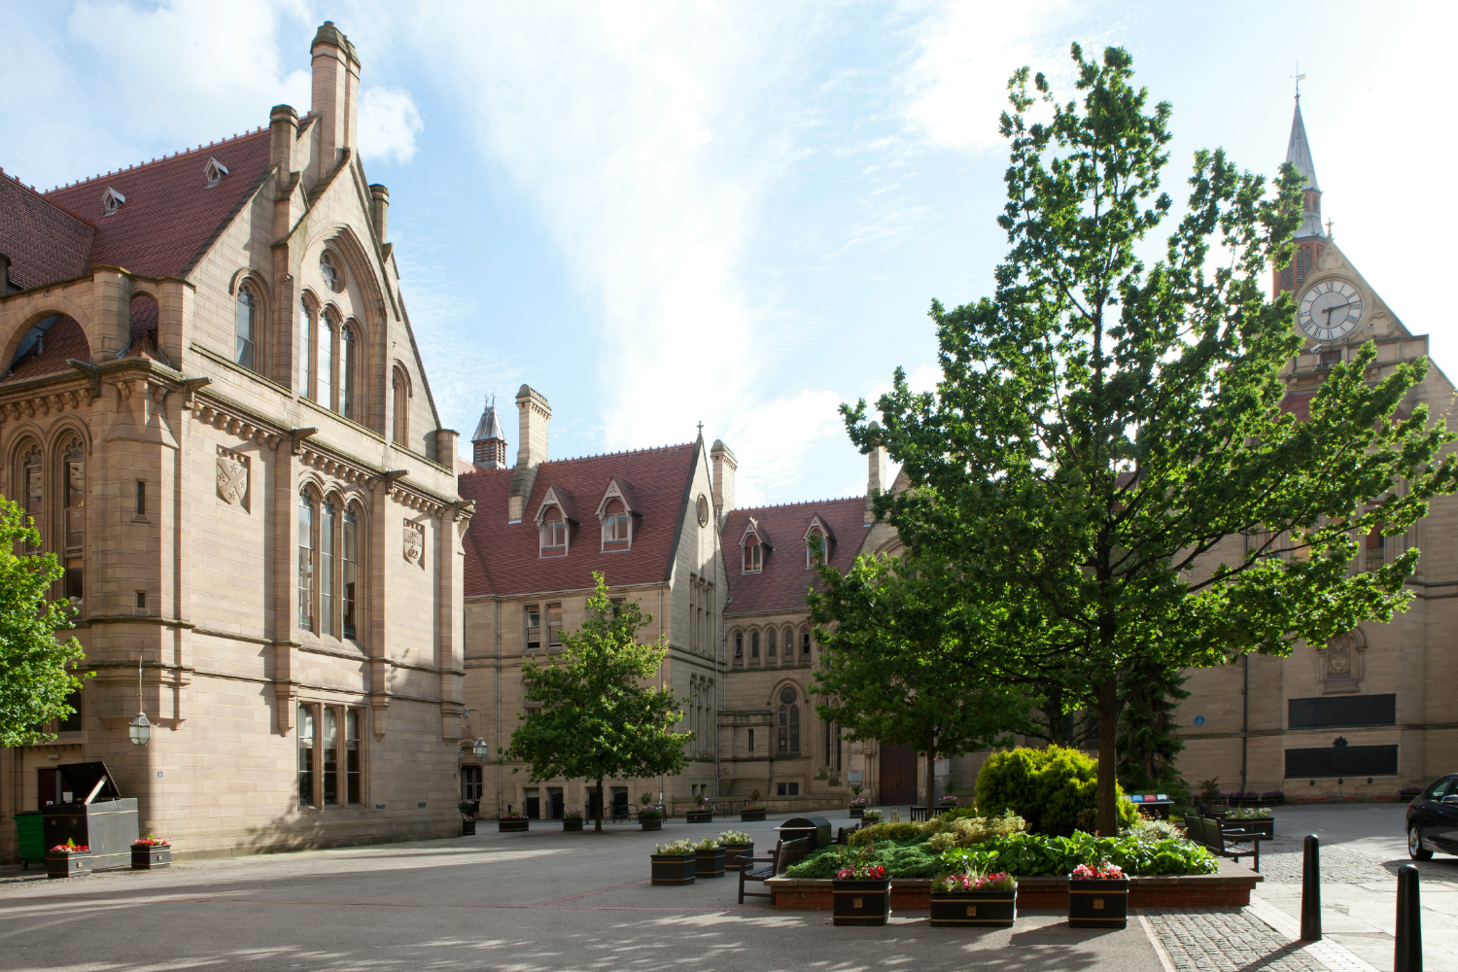

What we do
This four-week programme will introduce you to the history, contexts, principles and practice of science and health communication.

Programme details
You will get the opportunity to learn more about the different facets of science and health communication through our summer school programme.
A typical week on the Science Communication International Summer School will include lectures, seminar discussions, field trips, independent research and group work.
In addition to working with University of Manchester staff； you will also meet and be mentored by current science communication MSc and PhD students.
There will be field trips and visits to sites such as Jodrell Bank Discovery Centre, The Christie Hospital and Manchester Cancer Research Centre, Chester Zoo and The Science and Industry Museum.

Topics include:
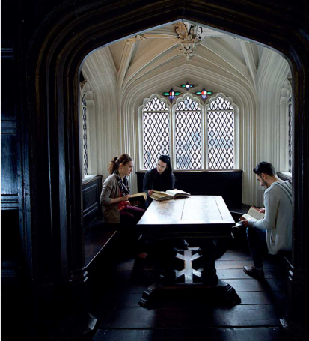
-Science and health journalism in the internet age
-Museums: Who and what are they for?
-Science communication and fictional media
-Communicating health and environmental risks
-Children and science: Educational opportunities and challenges
-Engaging with patients and the public around medical research
-Social and digital media: Expanding expertise?
-From colonialism to conservation: Zoos and science communication

